Motoshige Itoh
Professor Emeritus, The University of Tokyo
Professor of International Social Sciences,
Gakushuin University, Tokyo, Japan

Motoshige Itoh is professor of international social sciences at Gakushuin University. He was professor of economics at the Graduate School of Economics, the University of Tokyo, April 1996 through March 2016 and was the dean of the graduate school of Economics, the University of Tokyo, Oct. 2007 through Sept. 2009. He has been in various positions advising prime minister as well as in Japan. Currently, he is a member of the Council on Economic and Fiscal Policy. He received BA of Economics from the University of Tokyo in 1974 and Ph.D of Economics from the University of Rochester in 1979.
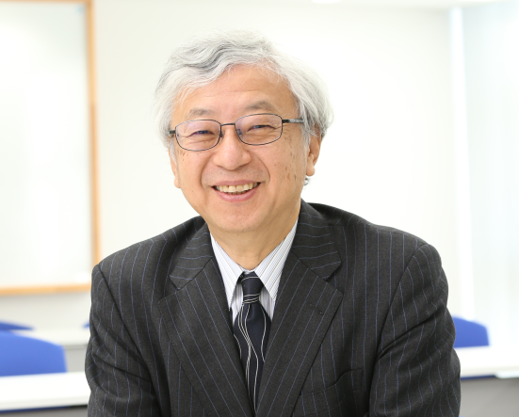

During the early period of academic career he published various papers in international leading journals such as Journal of Political Economy, Quarterly Journal of Economics, Review of Economic Studies, and Journal of Economic Theory. Later he is more involved in policy issues in Japan and published more than 40 books on various aspects of policy issues. He regularly writes for several newspapers and magazines.

